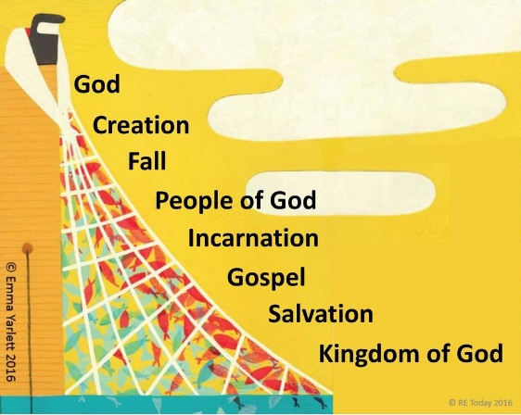
Year 5/6 RE Knowledge Organiser: Incarnation
 | Key Vocabulary and Definitions
Advent | The period leading up to Jesus’ birth.
Incarnation | The belief that God took human form by becoming Jesus.
Messiah | The promised saviour.
Old Testament | The first part of the Bible which was completed before Jesus Christ was born.
Prophecy | A prediction of what will happen in the future.

Was Jesus the Messiah?

Key Facts
- Jesus was Jewish.
- Christians believe Jesus is God in the flesh.
- They believe that his birth, life, death and resurrection were part of a longer plan by God to restore the relationship between humans and God.
- The Old Testament talks about a ‘rescuer’ or ‘anointed one’ — a messiah.
- Christians believe that Jesus fulfilled these expectations, and that he is the Messiah. (Jewish people do not think Jesus is the Messiah.)
- Christians see Jesus as their Saviour.






