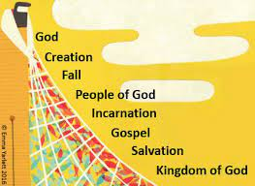
Year 5/6 RE Knowledge Organiser: Salvation

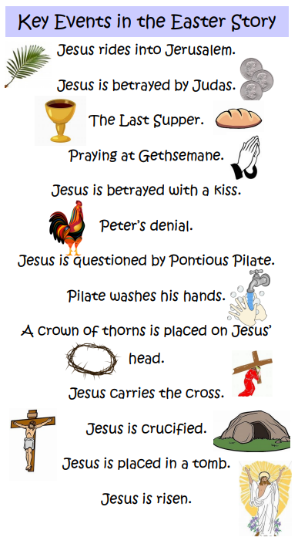
What difference does the resurrection make to Christians?
to Christians? make
to Christians?
Why
 | Key Vocabulary and Definitions
Ascension | The action of Christ rising into Heaven after the Resurrection.
Crucifixion | A form of execution (killing) by being bound or nailed to a cross.
Holy Week | The week before Easter, when Christians remember the events leading up to Jesus’ death and resurrection.
Incarnation | God in the flesh.
Jerusalem | Capital of Israel, where Jesus entered on Palm Sunday to celebrate Passover.
Luke | One of the 12 disciples and writer of the gospel of Luke in the bible.
Resurrection | Coming back to life after being dead.
Sacrifice | An offering for God or others, Christ sacrificed himself as an offering on the cross for our sin.
Salvation | Being saved from sin, Jesus death and resurrection means our relationship with God is restored.
‘And if Christ has not been raised, then your faith has nothing to it; you are still guilty of your sins.’
Paul in 1 Corinthians 15:17

‘Jesus, a man who was completely innocent, offered himself as a sacrifice for the good of others, including his enemies, and became the ransom of the world. It was a perfect act.’
Gandhi

