Key Vocabulary and Definitions
Air resistance | A type of friction caused by air pushing against any moving object.
Force | A push or pull.
Friction | The resistance that one surface or object encounters when moving over another.
Gears | A toothed wheel that works with others to alter the relation between the speed of a driving mechanism (e.g. engine) and the speed of the driven parts (e.g. the wheels).
Gravity | The pull that Earth exerts on an object, pulling it towards Earth’s centre.
Levers | A rigid bar resting on a pivot that is used to move a heavy or firmly fixed load.
Mass | The weight measured by an objects acceleration under a given force or by the force exerted on it by gravity.
Pull force | To draw or haul towards oneself or itself, in a particular direction.
Pulleys | A wheel with a grooved rim around that changes the direction of a force applied to the cord.
Push force | To move something in a specific way by exerting force.
Upthrust | The force that pushes an object up.
Water resistance | A type of friction caused by water pushing against any moving object.
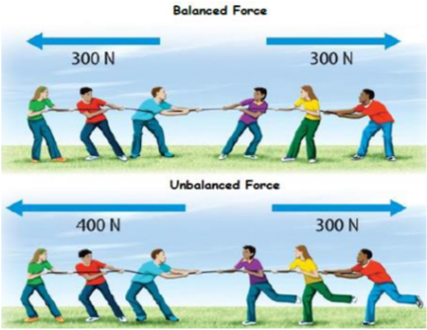
Y5/6 Science Knowledge Organiser: Forces



