Key Vocabulary and Definitions
algae | A single or multi-cellular organism that has no roots, stems or leaves and is often found in water.
bacteria | Tiny little organisms that are everywhere around us.
classification | The arrangement of organisms into orderly groups based on their similarities and presumed evolutionary relationships.
fungi | A classification or group of living organisms. This means they are not animals, plants, or bacteria.
invertebrate | An invertebrate animal does not have a backbone and 97% of creatures belong to this group.
micro-organism | An organism which is microscopic, making it too small to be seen by the human eye.
organism | An individual animal, plant or single-celled life form.
species | A group of closely related organisms that are very similar to each other and are usually capable of producing offspring.
taxonomy | The science of naming, identifying and classifying organisms.
vertebrate | A vertebrate animal is one that has a backbone.
virus | A small infectious agent that replicates only inside the living cells of an organism.
Y5/6 Science Knowledge Organiser: Living Things and Their Habitats - Classification
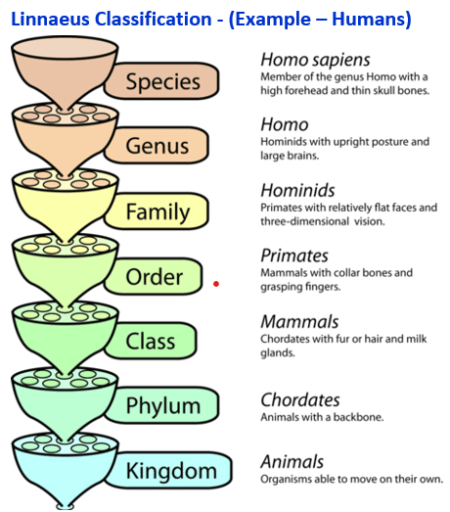
Carolus Linnaeus (1707-1778)
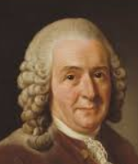

In 1735, Swedish Scientist Carl Linnaeus first published a system for classifying all living things. An adapted version of this system is still used today: The Linnaeus System.



