Key Vocabulary and Definitions
Dissolve | When something solid mixes with a liquid and becomes part of the liquid.
Evaporation | The process of turning from liquid to vapour.
Gas | An air-like fluid substance which expands freely to fill any space available.
Insoluble | Unable to be dissolved.
Irreversible | Cannot be reversed back to its original state.
Liquid | A substance that flows freely but can be measured by volume e.g. water or oil.
Magnetic | Capable of being magnetised or attracted by a magnet.
Material | The matter from which a thing is or can be made from.
Reversible | Able to be reversed back to its original state.
Solid | Firm and stable in shape, not a liquid or fluid.
Soluble | Able to be dissolved.
Solution | A mixture where one substance is dissolved into another.
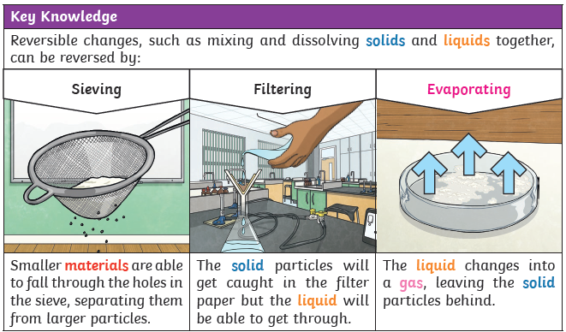
Y5/6 Science Knowledge Organiser: Properties of Materials (Cycle A)



