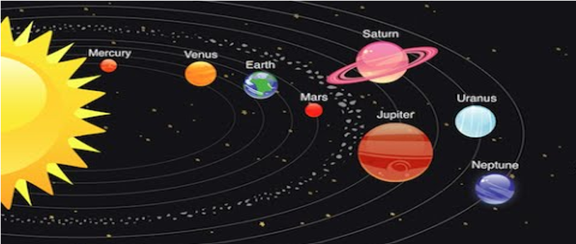
Y5/6 Science Knowledge Organiser: Earth & Space
Key Vocabulary and Definitions
astronomer | Someone who studies or is an expert in astronomy (space science).
axis | An imaginary line that Earth rotates around running from the North Pole to the South Pole.
dwarf planets | Similar to the Solar System’s eight planets but they are smaller.
geocentric model | A belief people used to have that other planets and the Sun orbited the Earth.
heliocentric model | The structure of the Solar System where the planets orbit around the Sun.
moon | A natural satellite which orbits Earth or other planets.
orbit | To move in a regular, repeating curved pathway around another object.
planet | A large object, round or nearly round, which orbits the Sun.
satellite | An object in space that orbits something else, for example the Moon is a satellite of Earth.
sphere | A round 3D shape like a ball.
star | A giant ball of gas held together by its own gravity.
Sun | A huge star that Earth and the other planets in our solar system orbit around.

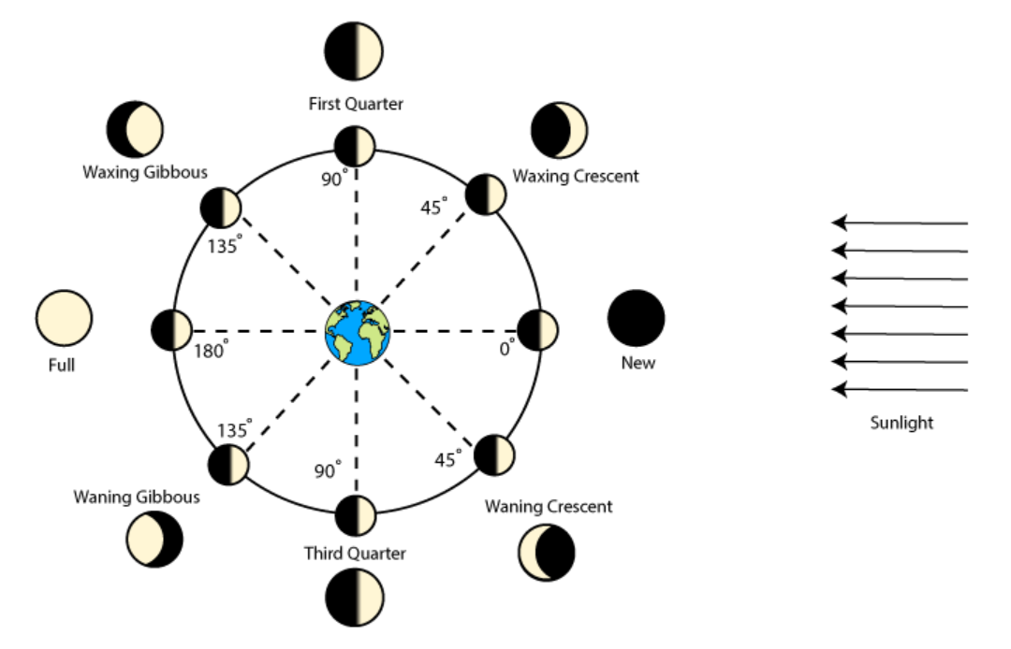
Phases of the Moon



