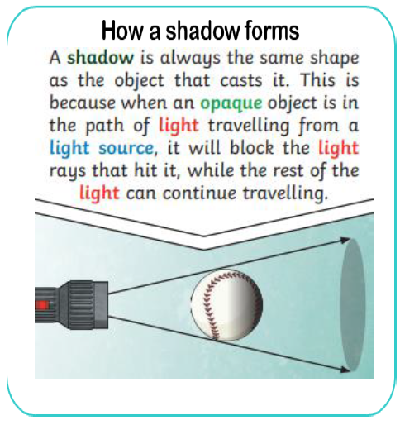
Y5/6 Science Knowledge Organiser: Light (Cycle B)
Key Vocabulary and Definitions
Light Source | Something that provides light, whether it be a natural or artifical (e.g. the sun, a torch).
Opaque | Something that cannot be seen through and does not allow light to pass through it.
Reflects | When light from an object is reflected by a surface, it changes direction.
Shadow | Formed when light from a source is blocked by an opaque object.
Translucent | Something that some light passes through, but the light is scattered, so you can't see clearly through it.
Transparent | Something that light completely passes through, and you can see clearly through it.


