Key Vocabulary and Definitions
Alloy | A metal made by combining two or more metals to improve its properties.
Archaeologist | Someone who learns about history through excavating sites and analysing evidence.
Artefact | Anything made, used, or modified by humans.
Bronze | A metal alloy made from a mixture of copper and tin. It is a much harder and more long-lasting material.
Celts | A powerful Iron Age tribe.
Druid | A Celtic priest.
Hillforts | Forts built on a hill surrounded by a series of banks, ramparts and ditches.
Iron | A metal that is stronger and harder than bronze.
Prehistoric | The time before written history began.
Roundhouse | An iron age home with a central pole to support the roof.
Sacrifice | Killing an animal or person, or offering important belongings to a god or goddess.
Tribe | A group of people, often related through family, culture and language, usually with one leader.
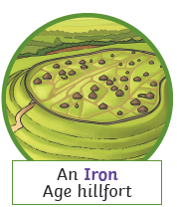
Y5/6 The Stone Age To the Iron Age Knowledge Organiser



