Key Vocabulary and Definitions
channel | The course in the ground that a river or water flows through.
dam | A barrier built to hold back water.
deposition/deposit | When rocks and other materials that have been eroded are dropped off further along the river.
discharge | The amount of water flowing along a river per second.
evaporation | The process of turning from liquid to gas.
erosion | Rocks and other river materials are picked up by the water and moved to another place along the river.
mouth | The point where a river joins the sea.
source | The place where a river begins.
tributaries | Rivers that join up with another river.
water vapour | Water in the form of gas.
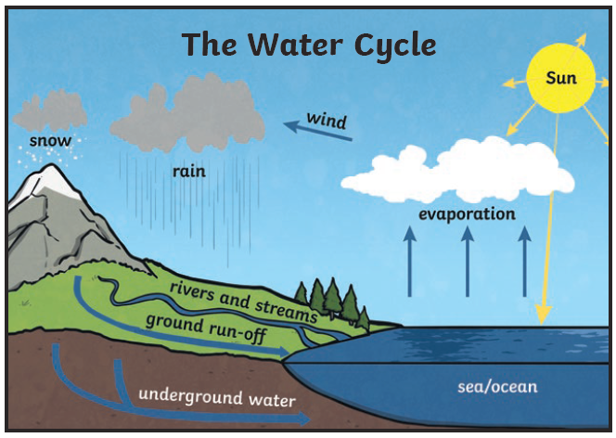
Y5/6 Raging Rivers Knowledge Organiser


