Y5/6 World War 1 Knowledge Organiser
Key Dates
June 1914: Assassination of Franz Ferdinand.

August 1914: Germany invades Belgium. Britain declares war on Germany.

October 1914: Battle of Ypres.

December 1914: Christmas truce.

April 1915: Gas attack on Ypres.

February 1916: Britain introduces conscription.

July 1916: Battle of the Somme begins.

July 1917: The United States declares war on Germany.

November 1918: Armistice (end of World War One).

June 1919: Treaty of Versailles signed.
Key Vocabulary and Definitions
Armistice | A formal agreement of warring parties to stop fighting.
Artillery | Large guns used in warfare.
Conscription | The requirement by law to join the armed forces.
Front Line | The area where the armies are engaged in fighting.
The Great War | The name used for World War One at the time.
No Man’s Land | The area of land between two enemy trench systems.
Treaty | A written agreement between two or more countries.
Trench | Long ditches dug into the ground where soldiers lived.
Triple Alliance | Central Powers: Germany, Austria-Hungary and their allies.
Triple Entente | Great Britain, France and Russia.
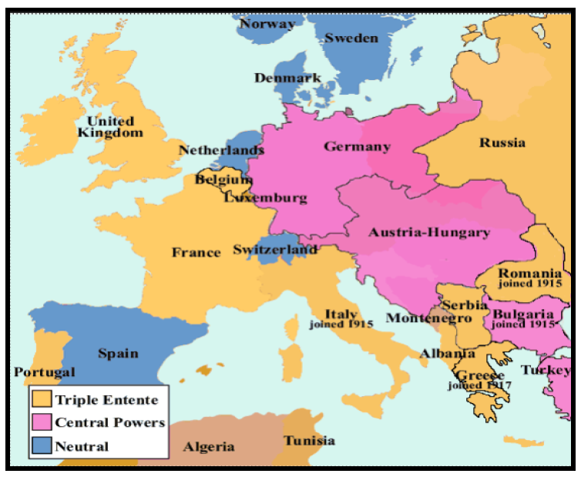
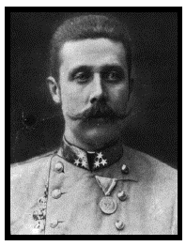
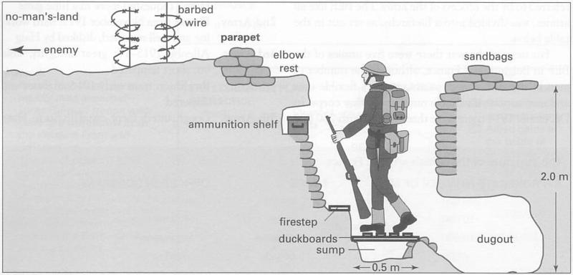
Archduke Franz Ferdinand
The assassination of Franz Ferdinand (Archduke
of Austria)
sparked the
outbreak of
World War
One.

