Key Dates
4th October 1957 | The first artificial satellite – Sputnik 1.
3rd November 1957 | The first dog in space – Laika.
January 31, 1961 | First chimpanzee in space – Ham.
12th April 1961 | The first person in space – Yuri Gagarin.
16th June 1963 | The first woman in space – Valentina Tereshkova.
18th March 1965 | The first spacewalk – Alexei Leonov.
20th July 1969 | The first person on the moon – Neil Armstrong.
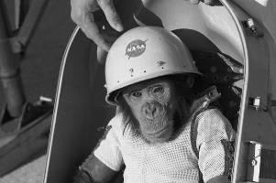
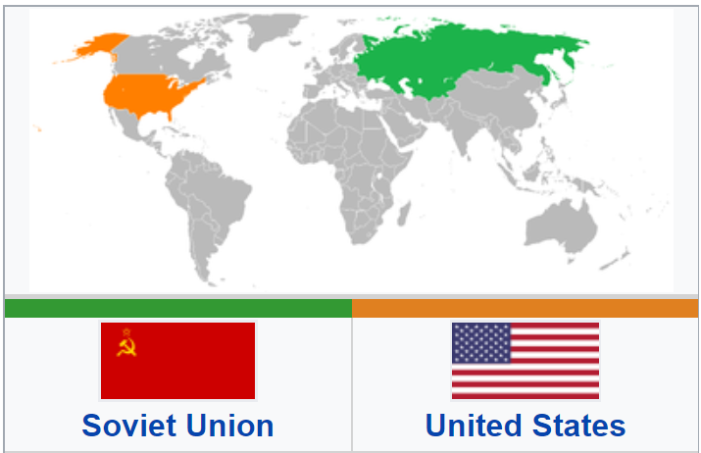
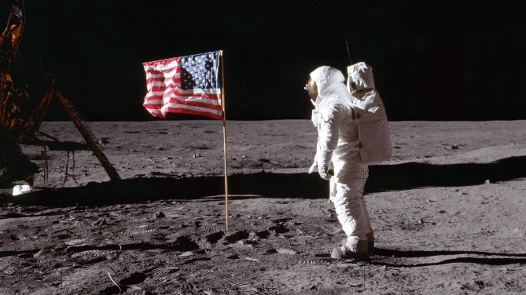
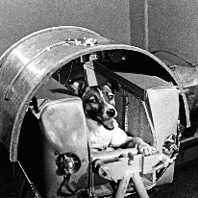
Y5/6 Knowledge Organiser: Space
Quotes
“That's one small step for man, one giant leap for mankind." Neil Armstrong
“We choose to go to the moon in this decade and do the other things, not because they are easy, but because they are hard…”
John F. Kennedy
Key People

Helen Sharman: The first British person in space.

Neil Armstrong: The first person on the moon.

Yuri Gagarin: The first person in space.
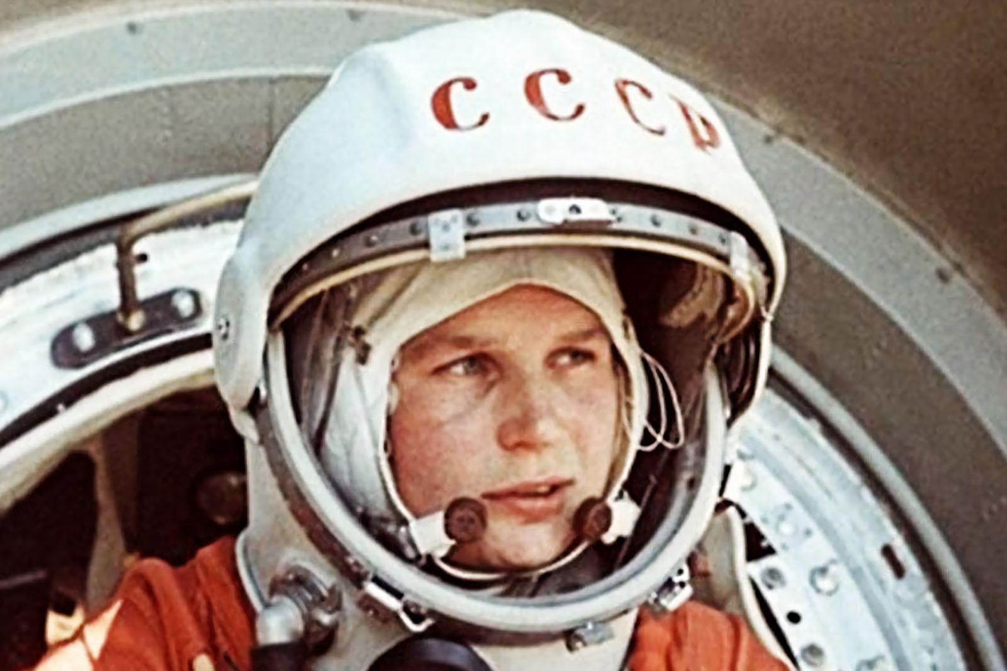
Key Vocabulary and Definitions
Apollo 11 | The spaceflight that first landed humans on the Moon.
astronaut | A person trained by a human spaceflight program to command, pilot, or serve as a crew member of a spacecraft.
cosmonaut | A person that is trained and certified by the Russian Space Agency to work in space.
lunar | Relating to the moon.
NASA | The National Aeronautics and Space Administration – a US agency responsible for the exploration and study of space.
Soviet Union | A country that no longer exists that was made up of fifteen republics in eastern Europe and northern Asia. It was also called the Union of Soviet Socialist Republics (USSR). Moscow was the capital of the Soviet Union.
Space Race | The Space Race was a competition of space exploration between the Soviet Union (now Russia) and USA, which lasted from 1955 to 1969.
spacewalk | When astronauts go outside their spacecraft, into space, in a space suit.


