Y5/6 Ancient Greece Knowledge Organiser
Term | Definition
Acropolis | A group of ancient temples that were built on a high, rocky hill in Athens. The word acropolis even means 'high city' in Greek.
Athens | The most powerful and civilised city state in Ancient Greece.
Boule | The boule was a group of 500 men who served for one year. They decided what issues to take to the Ekklesia. They were chosen randomly.
City State | A city that had its own government and rules the area around it.
Democracy | Democracy is a fair political system where all adults vote for an elected government.
Dikasteria | The Dikasteria, or popular courts, was a group of 500 jurors who dealt with crimes. There were no rules or police so the Dikasteria decided what would be tried and what the sentences would be.
Ekklesia | The Ekklesia was the main assembly of citizens who met 40 times a year to make laws and decisions.
Mount Olympus | The highest mountain in Greece and the mythological home of the Greek Gods, primarily twelve Olympian Gods.
Olympics | An athletic event held by the Ancient Greeks every four years.
Parthenon | An Athenian temple.
Sparta | City State in Ancient Greece famous for its powerful army.
Titans | The Titans were the first Greek gods.
Tyrant | The ruler of a Greek city-state like a king.
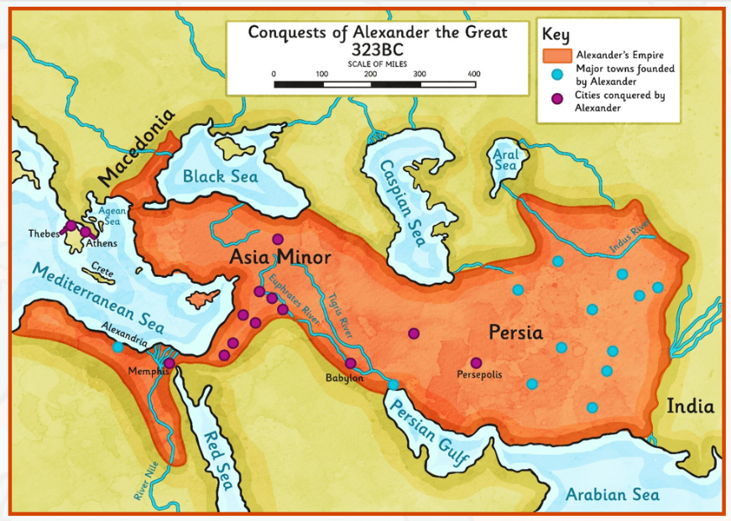
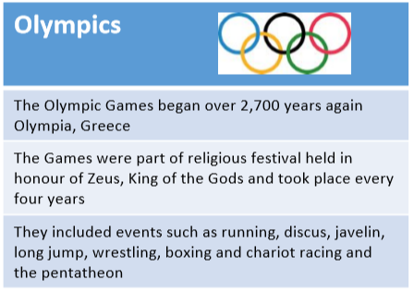
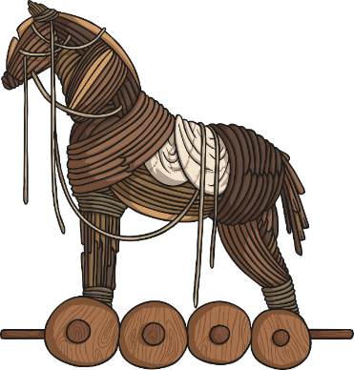

Greek Gods & Godesses
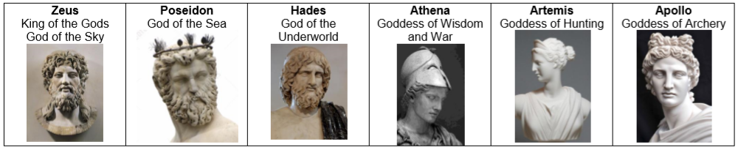

Ancient Greece Timeline


