Key Vocabulary and Definitions
atlas | A collection of maps often of each country in the world.
compass | A tool used for showing direction.
digital map | A map that uses technology such as a satnav.
easting | The numbers used in a grid reference that run west to east.
grid references | The numbered squares on a map used to locate a place.
National Grid | A system used to split Great Britain into 100km squares.
northing | The numbers used in a grid reference that run south to north.
Ordnance Survey maps | Detailed maps of Great Britain where each square represents 1km squared (1km²).
symbols | Small pictures, letters or lines that represent a feature.
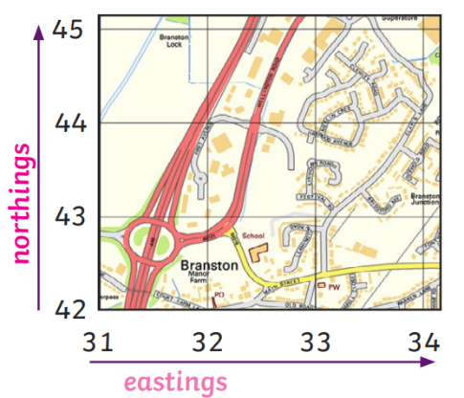
Y5/6 Marvellous Maps Knowledge Organiser


