Y5/6 World War 2 Knowledge Organiser
Key Dates
1st September 1939
Germany invades Poland

3rd September, 1939
Britain and France declare war on Germany (start of WW2)

January, 1940
Rationing introduced across the UK

May to June, 1940
Dunkirk evacuated and France surrenders to Germany
Germany uses blitzkrieg to take over much of Western Europe

July, 1940
Germany launches air attacks on Great Britain (The Battle of Britain and the Blitz begins)

7th May 1945
Germany surrenders & victory in Europe is declared the next day.
Key People

Quotes
“…we shall fight on the beaches, we shall fight on the landing grounds, we shall fight in the fields and in the streets, we shall fight in the hills; we shall never surrender…”
Winston Churchill
“In war, whichever side may call itself the victor, there are no winners, but all are losers.”
Neville Chamberlain
Winston Churchill: UK Prime Minister, 1940 - 1945
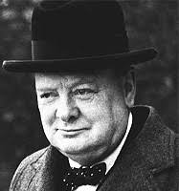
Neville Chamberlain: UK Prime Minister, 1937 - 1940
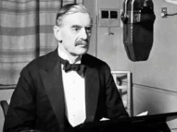
Adolf Hitler: Leader of the Nazi Party and Chancellor of Germany, 1933 – 1945
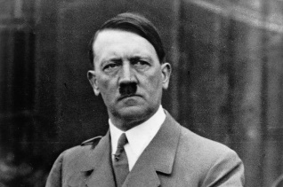
Key Vocabulary and Definitions
Allies | Countries which fought on the British side (including: USA, Great Britain, France, Russia (1941-1945).
Evacuee | Someone who was evacuated, moved from a danger area to a safer place (normally from the cities to rural areas).
Black out | System of ensuring no lights were visible after dark so that buildings could not be spotted by enemy planes.
Rationing | The controlled distribution of scarce resources (mainly food & clothing).
Air-raid shelter | A building to protect people from bombs dropped by planes.  Anderson Shelter: Made of corrugated iron. Usually at the end of the garden.  Morrison Shelter: Metal cage used inside the house. Could double as a kitchen table.
Axis | Countries which fought on the German side (including: Italy, Germany, Japan, Russia (1939-1941).
Nazi | Member of the fascist German political party which came to power in 1933. Symbol = swastika
Blitz | Series of aerial bombing raids on the UK, mainly cities including London, Bristol & Nottingham.
Holocaust | Mass murder of Jews and other groups of people by the Nazis.
Blitzkrieg | Translated as ‘lightning war’. German quick strike invasion of Western Europe.
Luftwaffe | The German Air Force (responsible for the Blitz).

