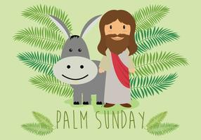
Infant 1 R.E - Salvation
Why do Christians put a cross in an Easter garden?

Key Words
Easter
Lent
Jerusalem
Palm leaves
Hosanna
Bread and wine
Pray
Cross
Tomb
Resurrection
Love
Save

Key Facts
- To lent is the time when we are getting ready for Easter
- Easter is a special time for Christians when they remember Jesus last week on Earth.
- Jesus came to earth to show Gods love for all of us and so we try to show love to others.
- To know each part of the Easter story – palm Sunday, last supper, Jesus praying in the garden, Jesus’ death and resurrection.
- Supported by work on life cycles

Core Texts
The Easter story

The Garden, the Curtain and the Cross by Carl Laferton



