Key Facts
- Minibeasts their habitats and life cycles-spiders, ladybirds, caterpillars, butterflies, frogs, bees and worms
- Spiders have eight legs and eight eyes, they spin webs and eat insects.
- Ladybirds are insects. They have six legs and wings so they can fly. Their bright colours and spots tell predators not to eat them. They lay eggs.
- Life cycle of a butterfly- it lays some eggs, a caterpillar emerges, it eats and grows bigger, it spins a cocoon and stays inside for 2 weeks. A butterfly emerges.
- Life cycle of a frog - they lay eggs called frog spawn. A tadpole emerges from the egg. The tadpole begins to change shape- it grows front legs then back legs, it is a froglet. Eventually its tail disappears and it is a frog. Frogs eat plants and insects they are amphibians.
- Worms have no arms, legs or eyes.. They have five hearts and can regrow parts of their body if they are cut off. They a very good for the soil.
- Seeds need light, soil and water to grow.

Key Words
spider ladybird
caterpillar butterfly
frog bee worm
predator prey
Egg cocoon
frog spawn
tadpole
amphibians
metamorphosis
seed germinate
root stem

Foundation Stage Time for a Change

Core Texts
The very busy spider
The bad tempered ladybird
Hungry caterpillar
Superworm
Snail trail
How the snail found its colours
The bee Book

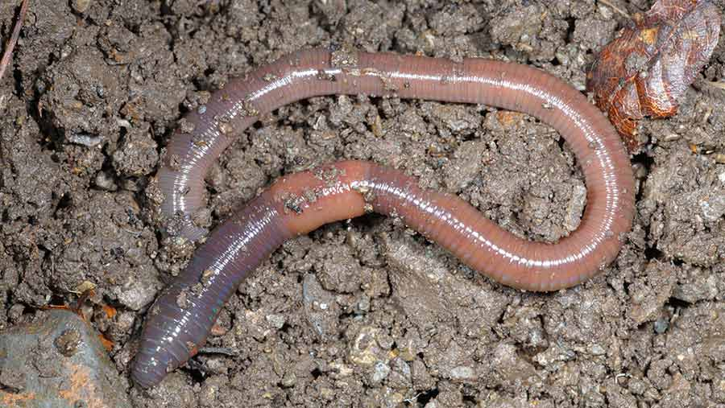
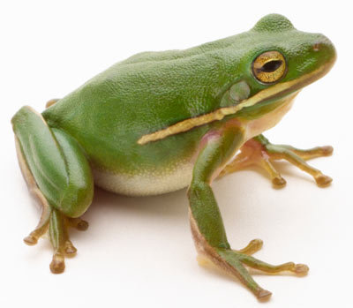
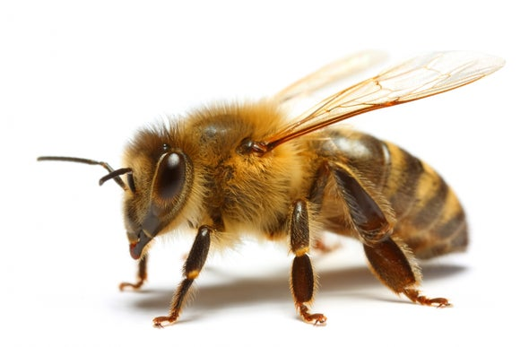

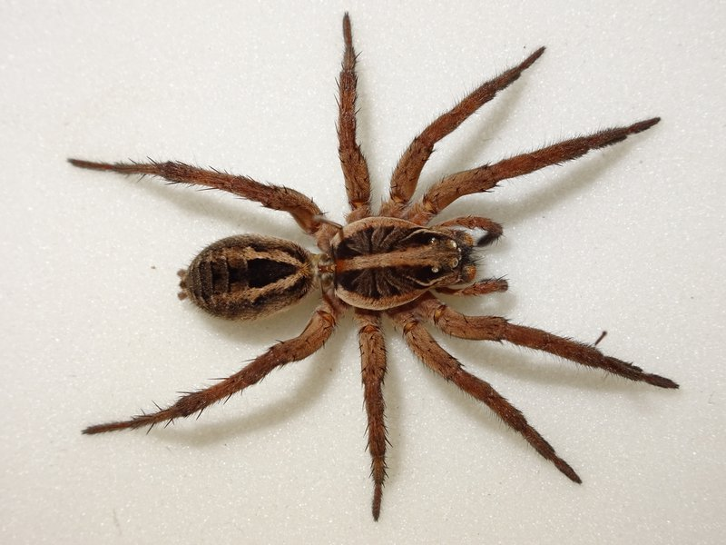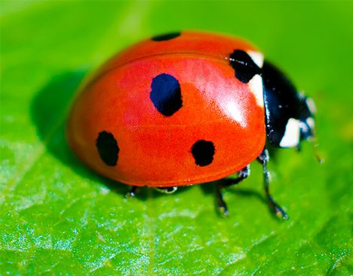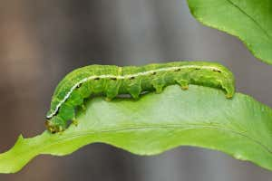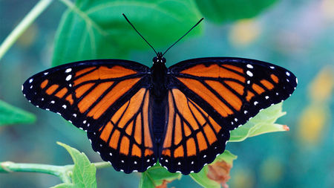
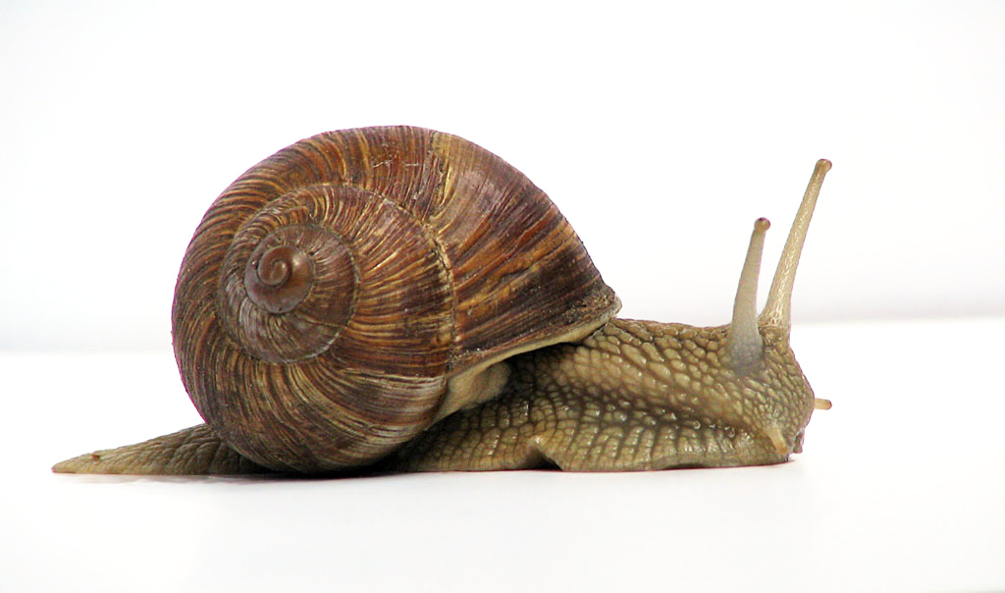
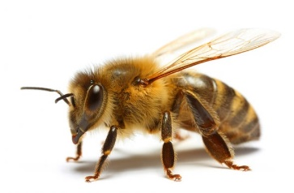
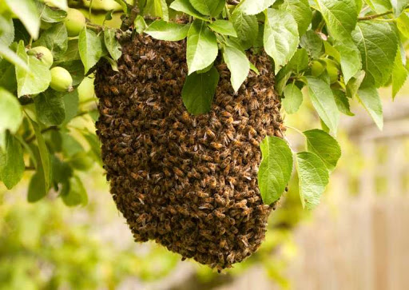
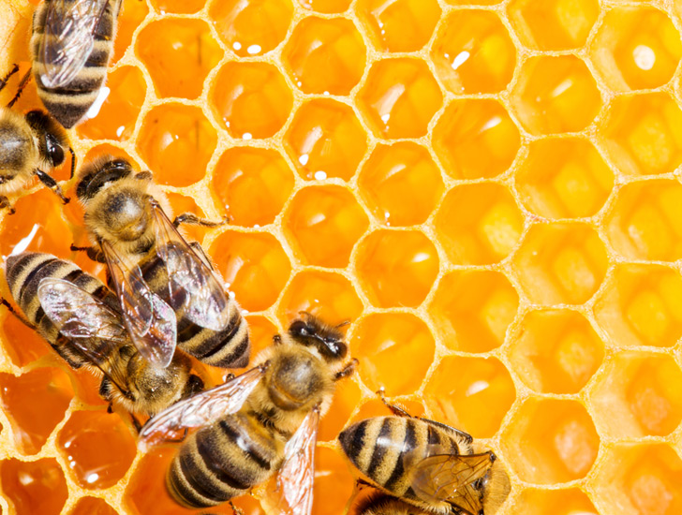
What do you know about minibeasts?


