Key Words
vegetable names
fruit names
crop
tractor
sow
harvest
combine harvester
flour
yeast
kneed
farm
farmer
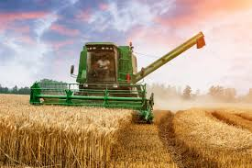

Foundation Stage Harvest
Key Knowledge
- To know and identify different types of vegetables/fruit
- To understand that our food comes from farms
- To understand how bread is made
- To understand what crops need to grow

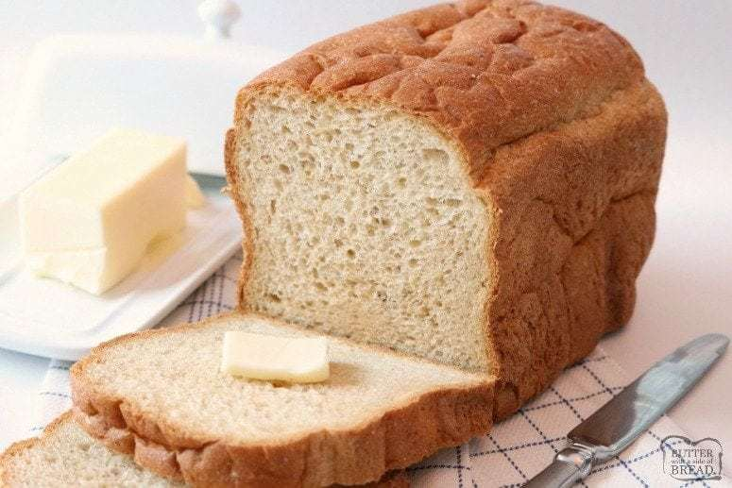
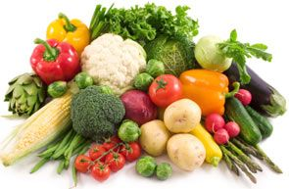
Core Texts
Oliver’s fruit salad/veg Scarlett Bean Little Red Hen


