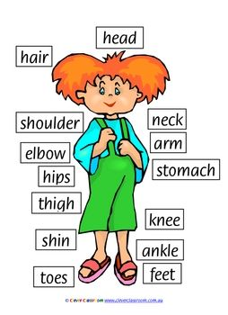
Key Words
head, hair, face
eyes, nose, mouth, teeth, tongue
ears cheeks, chin
neck, shoulder arms, elbow, wrist fingers, chest, stomach, hips, leg, thigh, knee, shin ankle, feet, toes
family
like
dislike
address

Foundation Stage Wonderful Me
Key facts/questions
- Naming different parts of the body
- Who is in your family?
- Do you have any pets?
- What do you like?
- What do you dislike?
- Where do you live?
- We can take care of ourselves by eating food that is good for us, exercising, cleaning our teeth and washing.


