Activities –for Infants
Make a Teddy bear  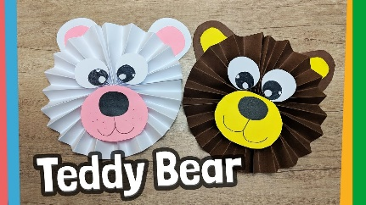 There is a you tube video at the link below to show you how-  https://www.youtube.com/watch?v=QbEfcjzPf8o | Design a Bear  Use the template in this resources section to design you own bear. Maybe give them a name and label your design. | Size ordering  (sheet in the resources section)  Cut out the bears and put them in size order from the largest to the smallest. | Shape Bear  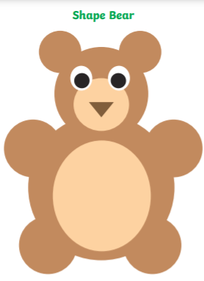  Print out the  sheets from  the resources,  cut out the  shapes to  make a bear
Older Children
Be an author…  Create a rhyming story that I can read to infant 1. | The things I treasure most…  Create a list of 5 things that are precious to you, your five most favourite things in the world. |  | Teddy bear quizzes  How well do you know your bears??Complete the two teddy bear quizzes below  https://www.bbc.co.uk/bitesize/articles/zrpw92p  https://www.bbc.co.uk/cbbc/quizzes/bp-teddy-bear-quiz

