Key vocabulary
Life processes
Life cycle
Joey
Habitat
Diet
Offspring
Habitat
Micro-habitat
Herbivore
Carnivore
Omnivore
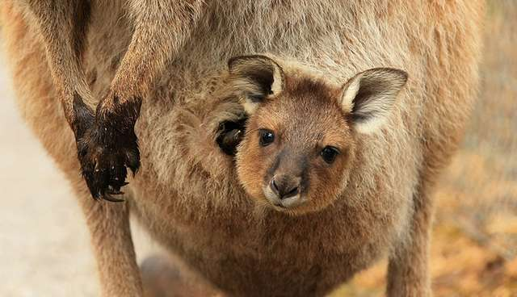
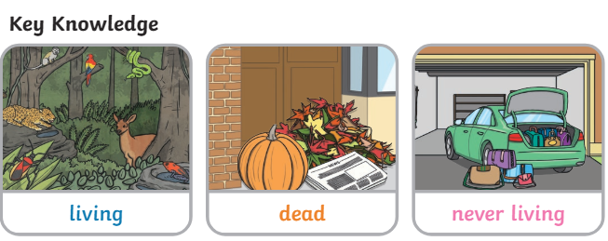
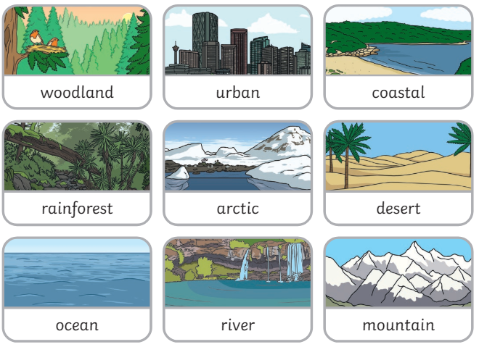
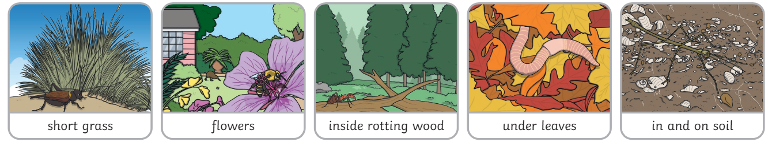
Examples of micro-habitats
Examples of habitats
KS1 Science: Habitats

Key facts/knowledge
Australia is home to a large variety of unusual animals.
Australia is home to over 750 different reptile species.
The Kangaroo is native to Australia. Native means ‘where something comes from’.
Kangaroos are marsupials which means they are a mammal that carries their baby in a pouch on the front of their tummies. Other Marsupials include the Wallaby, Opossum, Koala and Tasmanian Devil.
All baby marsupials are called ‘Joeys’.
A carnivore is an animal that eats another animal. This is also known as a meat eater.
A herbivore is an animal that eats plants, vegetation, nuts and seeds.
An omnivore is an animal that eats both meat and plants, vegetables, nuts and seeds.

