Key vocabulary
Aborigine
Indigenous
Civilisation
Hunting
Cave painting
Boomerang
Didgeridoo
Spear
Weapon
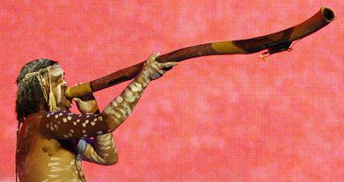
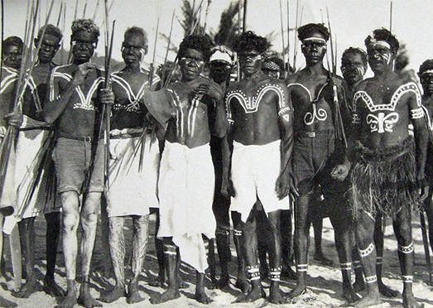
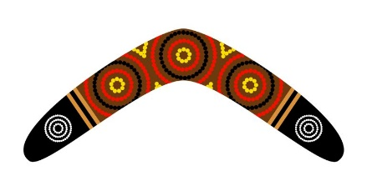
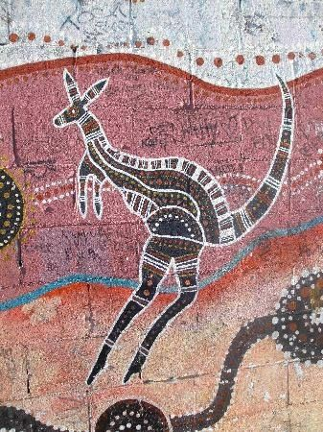
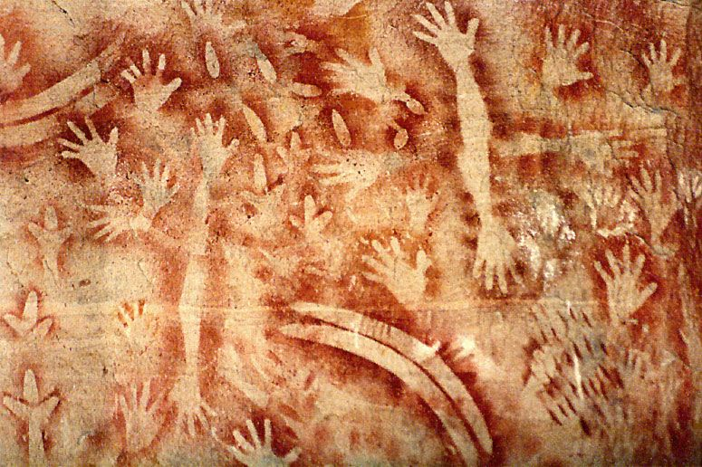
Ancient Cave Paintings
Aboriginal Tribes People
Aborigine playing the didgeridoo
Key facts/knowledge
Aborigines are the indigenous people of Australia which means they have been there since time began. They have been around for thousands of years and once lived together in tribes.
Aborigines made their own weapons used for hunting animals to eat. They made paint from ground rocks, dust and plants to decorate themselves and to create drawings in their caves. These drawings told stories.
Boomerangs were originally made from carved wood and were a type of weapon used to catch fast animals. They are designed to be thrown and then return back to the hunter.
Didgeridoos are probably one of the oldest instruments in the world. They are made out of hollow tree trunks and a deep sound is made by blowing through it.

Boomerang
KS1 History: Australia

