Key vocabulary
Country
Continent
Ocean
Population
City
Outback
Great Barrier Reef
Ayres Rock (Uluru)
Sydney Harbour Bridge
Sydney Opera House
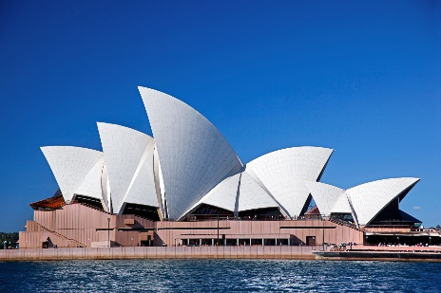
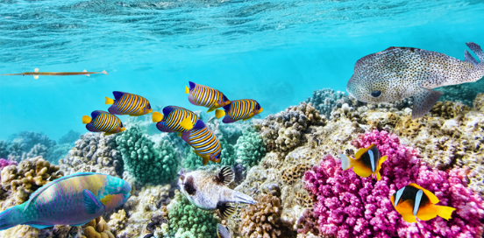
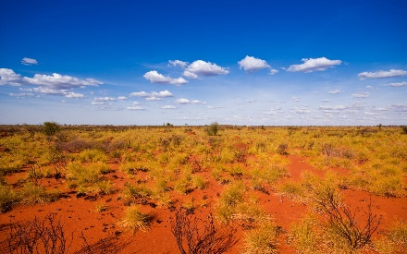
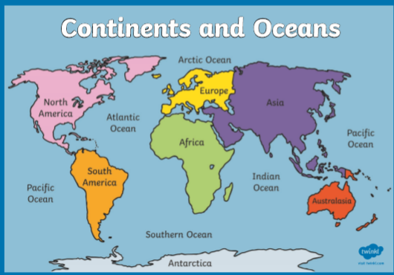
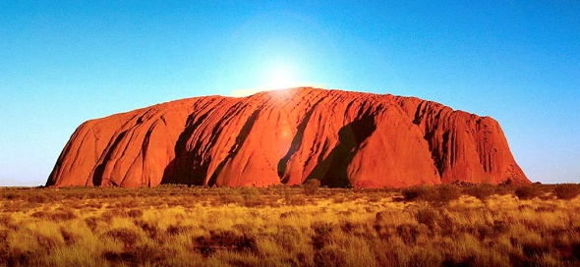
The Outback
Great Barrier Reef
Sydney Opera House
Key facts/knowledge
Australia is the 6th Largest country in the world.
It is part of the continent ‘Australasia’ along with New Zealand, Samoa, Papua New Guinea and many other countries and small islands.
There are 7 continents in the world; Antarctica, Asia, Africa, North America, South America, Europe and Australasia. We live in Europe.
There are 5 oceans of the world; The Pacific, The Atlantic, The Indian, The Southern and The Arctic Ocean.
The Capital City of Australia is Canberra.
There are many busy cities in Australia with lots of people and buildings but there are also large areas of desert which the Australians call ‘The Outback’.
The Great Barrier Reef is the world’s largest coral reef and is off the North Eastern coast of Australia. It is so huge; it can be seen from space!

Ayres Rock (Known as Uluru by the Aboriginal people)
KS1 Geography: Australia

