Key vocabulary
Gunthorpe Village
City
Country
Rural
River Trent
Fields
Houses
Bridge
Lock
Marina
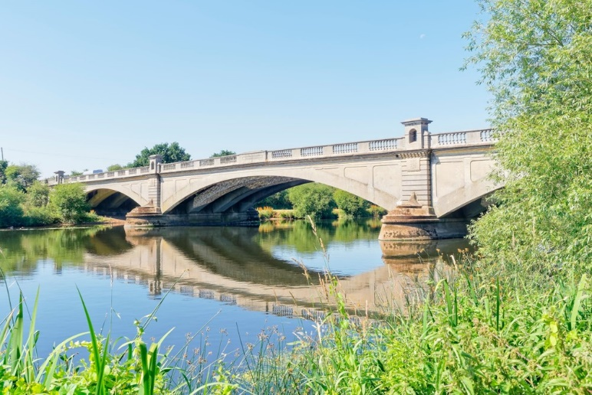
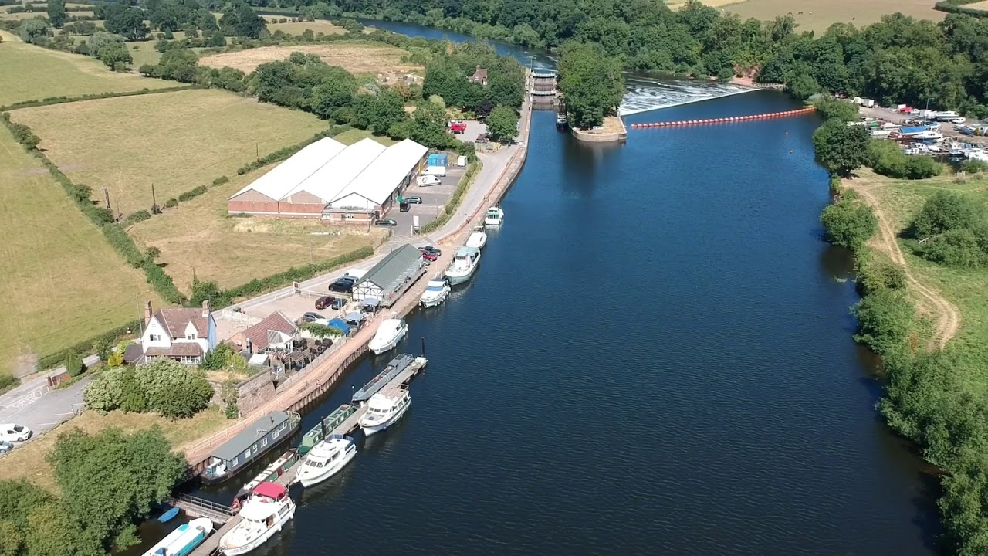
Key facts/knowledge
Our school is in a small village called Gunthorpe.
Gunthorpe is in the City of Nottingham.
Our school is in a rural location. This means that it is outside of the City and close to the countryside.
Many of our class live in Gunthorpe but some of us have homes in the surrounding villages.
Gunthorpe sits along the River Trent and has a bridge for people and vehicles to cross.
KS1 My Village & Me: Geography

Gunthorpe Bridge
Lock
Fields
River Trent
Marina

