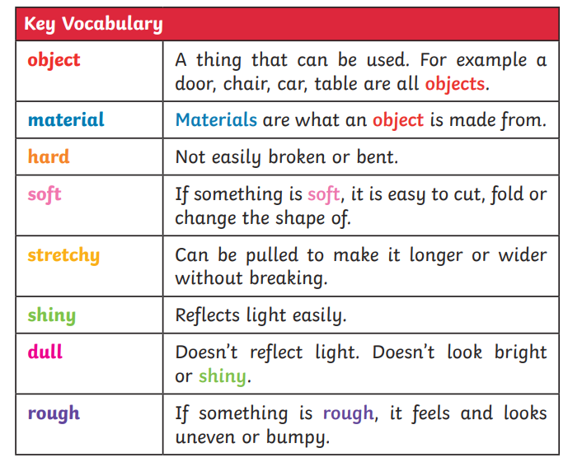
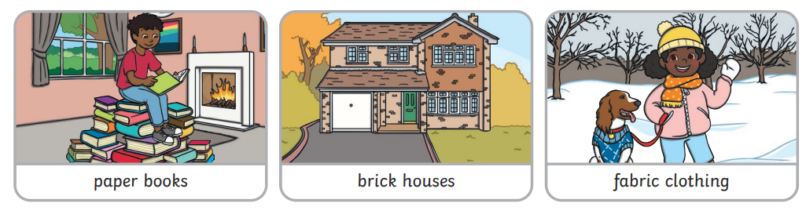
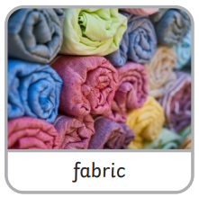
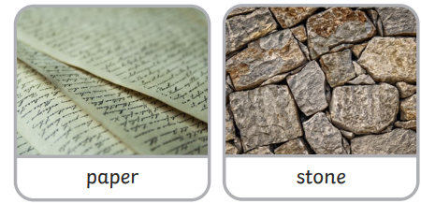
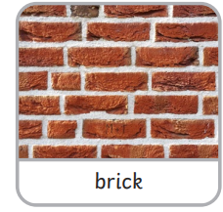
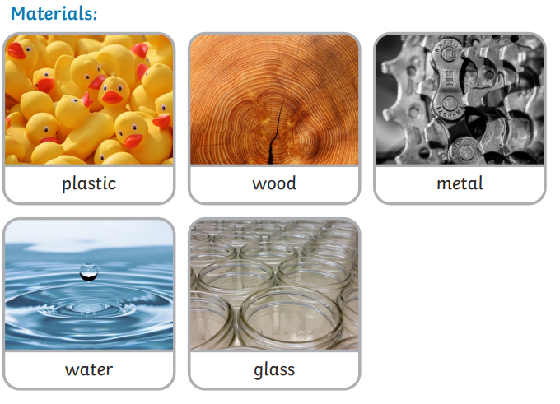
KS1 Everyday Materials: Science

Key facts/knowledge
- If something is waterproof it keeps water out. Umbrellas need to be waterproof to keep people dry. Non-waterproof materials let water in.

- If something is absorbent it will soak up liquid, if something is non-absorbent it won’t.

- Transparent objects can be seen through, like a window. Opaque objects can’t be seen through.

- Different materials have different strengths and have very different uses.

