Key vocabulary
Climate
Equator
Polar
Tropical
Temperate
Antarctica
Arctic
Expedition
Temperature
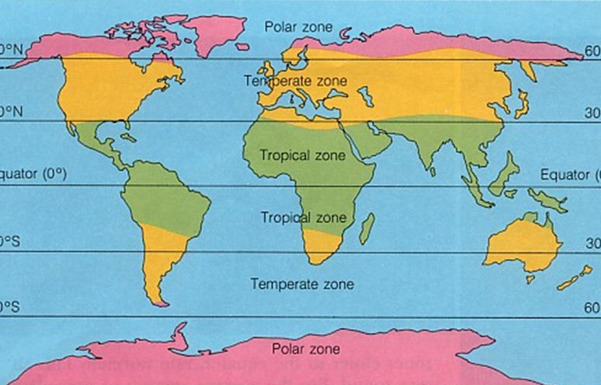
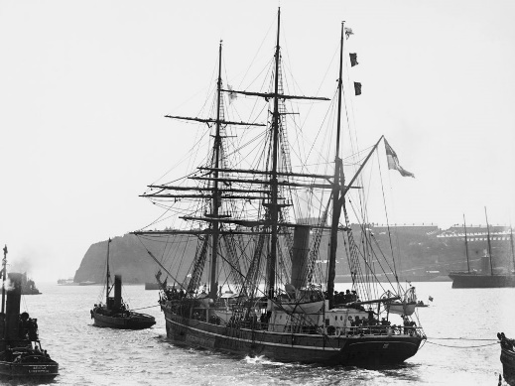
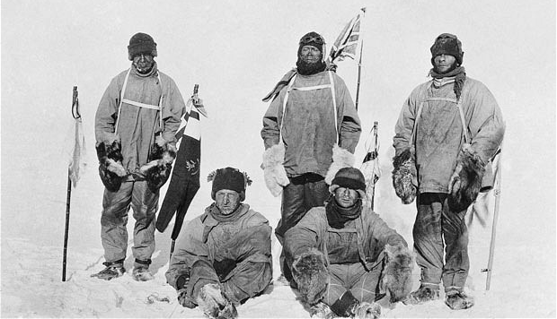
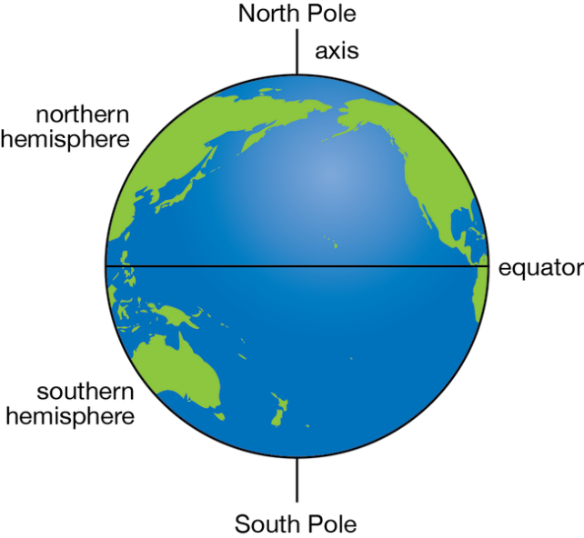

Key facts/knowledge
- The world is split into climate zones; hot, tropical, temperate and polar.
- The hottest countries lie along the equator.
- The coldest places on earth are the North and South Poles. These are the furthest places away from the equator.
- Sir Robert Falcon Scott led an expedition to reach the South Pole in 1910.
- He set sail from Cardiff, Wales on a ship called the Terra Nova in June 1910 and arrived at base camp, Antarctica in October 1910.
Climate zones on the world map
Sir Robert Falcon Scott and his team
The Terra Nova
KS1 The Big Freeze:
Geography and History

