Key vocabulary
Past
Present
Family Tree
Relatives
Generations
Milestones
Timeline
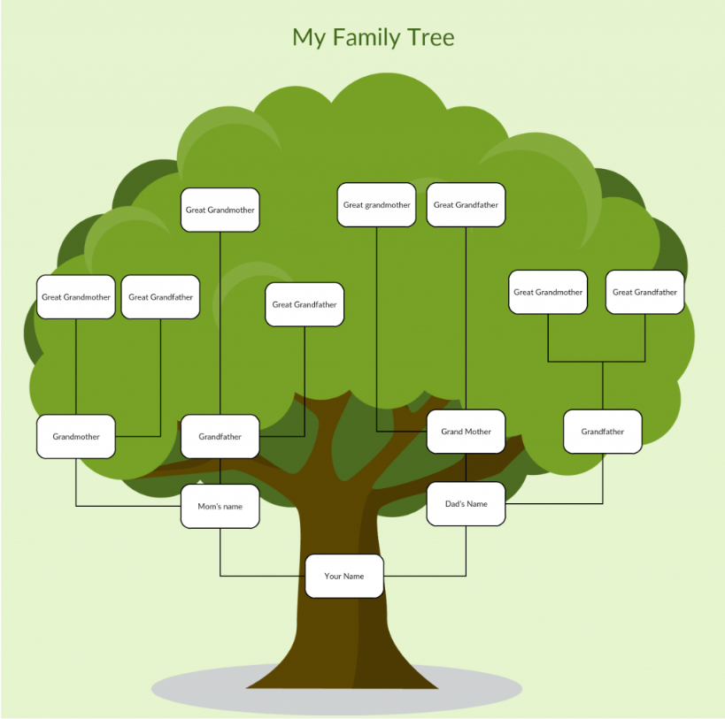
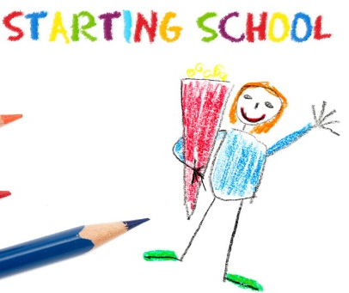
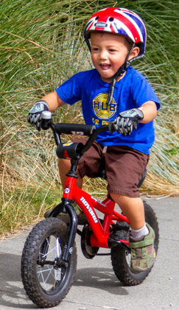
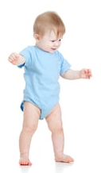

KS1 My Village & Me: History

Key facts/knowledge
Our relatives are the people in our family.
Family Trees are a way to map out our relatives to show the order of generations starting from the youngest to oldest.
We have some family members that are living today and some that are no longer living.
We mark our important milestones on a timeline such as taking our first steps, saying our first word, starting school etc.
First day at School
Learnt to ride a bike
First Tooth
First Steps

