‘Feeding Minds, Touching Hearts’

Admission Arrangements 2025-26

Parents who live in Nottinghamshire and wish to apply for a school place should use Nottinghamshire County Council’s coordinated admissions scheme which can be found on their website. Parents living outside Nottinghamshire should apply through their home LA.

Application for Places

Our school catchment area serves the villages of Gunthorpe and Caythorpe. In the event of under-subscription from our catchment area, we also welcome out of catchment applications. Our Published Admission Number (PAN) is 15.

Visit https://www.nottinghamshire.gov.uk/education/school-admissions for detailed information about schools admissions and to apply for a school place.

N.B. As of 1st September, 2021, there is a new statutory change involving children who were Internationally Adopted Previously Looked After Children but outside of England (IAPLAC – see definition below). This is a governmental change and does not need to be consulted upon.

Visits to School

Visits to school are welcome, please telephone the school office to make an appointment. You can get a flavor of our amazing school and what we learn and achieve by visiting our website at www.gunthorpeschool.co.uk In the autumn term we hold open days.

Applications for First Admission Places in Primary Education

Children will be admitted to the foundation stage (reception) in the September following their fourth birthday i.e. children who will reach their fifth birthday between 1st September 2025 and 31st August 2026. Parents can request that the date their child is admitted to school is deferred until later in the school year or until their child reaches compulsory school age in that year (school admissions code 2021, 2.17b and 2.17c) or parents can request that their child attends part time until their child reaches compulsory school age. Children must be attending school no later than the term after they are 5 years old. Pupils who have an Education and Health Care Plan (EHCP), where Gunthorpe C of E Primary School is named in the plan, will be admitted.

Admissions Criteria

If there are more applications than the 15 places available, the following admission oversubscription criteria will apply after those children with an Education, Health and Care Plan, which names the school, have been allocated.

Priority will be given to children in the following order:

- Children who are or have previously been looked after or Internationally Adopted Previously Looked After Children (IAPLAC).

A looked after child is a child who is (a) in the care of the Local Authority, or (b) being provided with accommodation by a Local Authority in the exercise of their social services functions in accordance with section 22(1) of the Children Act 1989 or at the time the application is made to school.

Previously looked after children are children who were looked after, but ceased to be so because they were adopted (or became subject to a child arrangements order or special guardianship order). This includes children who were adopted under the Adoption Act 1976 and children who were adopted under section 46 of the Adoption and Children Act 2002.

Child arrangements orders are defined in section 8 of the Children’s Act 1989, as amended by section 12 of the Children and Families Act 2014. Child arrangement orders replace residence orders and any residence order in place prior to 22nd April 2014 is deemed to be a child arrangements order. Section 14A of the Children Act 1989 defines a ‘special guardianship’.

Internationally Adopted Previously Looked After Children: To be eligible for IAPLAC priority, the child must appear (to the admission authority) to have been in state care outside of England (in the care of or accommodated by a public authority, a religious organisation, or any other provider of care whose sole or main purpose is to benefit society) and ceased to be in state care as a result of being adopted.

- Children who live in the catchment area at the time of admissions and have a sibling already on roll at Gunthorpe C of E Primary School.

- Children who live in catchment.

- Children out of catchment with siblings who are already on roll at Gunthorpe C of E Primary School

- Children with an parent or carer involved in a Church who is a regular Church worshipper or involved in the life and work of the Church of England, as attested to by the ‘Minister’ (e.g. Vicar/Priest in Charge), in writing.

- Children who live outside the Catchment Area without siblings already on roll at Gunthorpe C of E Primary School (allocated in terms of distance, nearest to the school first).

If places remain after applicants from the catchment area have been accommodated, places will be allocated as follows:-
- In the event of over-subscription in any criterion, where all applications are deemed equal, in the event of two distances being equal it will be measured to the next decimal point. If the measurements remain equal, for example children living in the same block of flats, lots will be drawn, and the process will be independently verified.

- Definition of regular worshipper means parent/guardian who have attended worship at least one Sunday a month over the previous year.

- Definition of ‘involved in the life and work of’ means parent/carer who can demonstrate specific involvement in the Church apart from regular worship throughout at least the previous year. Church based application – The applicant could provide a statement which was countersigned by a minister to confirm Church involvement.
Please note: In the event that during the period specified for attendance at worship the church has been closed for public worship and has not provided alternative premises for that worship, the requirements of these [admissions] arrangements in relation to attendance will only apply to the period when the church [or in relation to those of other faiths, relevant place of worship] or alternative premises have been available for public worship

Late Applications

Late applications (those received after the closing date) are processed in line with the coordinated scheme.

Multiple Births

Where a child of a multiple birth can be admitted, the other child/children will also be admitted in and outside the normal admissions round.

Waiting list

Children’s names will be added to the school’s waiting list if they are refused a place. The position on a waiting list is decided by the oversubscription criteria. No reference is made to the date an application has been received or whether a parent has appealed against the decision. Every time a child is added to a school’s waiting list will require the list to be ranked again in line with the published oversubscription criteria. If any applications are received that have higher priority within the admission oversubscription criteria, these will be placed higher than applications that may have been on the list for some time. Being on a waiting list does not mean that a place will eventually become available. If a place becomes available, the place will be allocated to the child who is top of the waiting list at that time. This will include all applications that have been received requesting a place at that school.

Waiting lists are held for admission to year groups reception to year 5 and are held until the end of the summer term. Waiting lists will close at the end of the summer term and parents would need to make a new application for the next academic year.

Right of Appeal

If a place is not offered, parents have the right of appeal. Such appeals against refusal of a school place, will be heard by an Independent Appeals Panel formed in accordance with the DfE School Admissions Appeals Code. The deadline for lodging appeals allows appellants at least 20 school days from the date of notification that their application was unsuccessful to prepare and lodge their written appeal. Details of the appeals process will be made available to all unsuccessful applicants at the time of refusal.

Fair Access Protocol

Gunthorpe C of E Primary School participates in the LA’s Fair Access Protocol as deemed reasonable (see NCC website for further information).

In Year Applications for Children other than into Reception (Foundation Stage 2)

We welcome applications for children to join us, either in September or any time during the School Year, who are older than initial school entry age (i.e. requesting entry into Years’ 1 to 6). In the event of over subscription the above criteria still apply. Please contact the School Office (0115 9663481) if you require any clarification on this or any other matter or would like to visit the school before submitting an application.

The school uses the same definitions as Nottinghamshire County Council and participates in Nottinghamshire County Council’s in-year coordinated scheme. Full details are available at www.nottinghamshire.gov.uk/admissions

Children outside the normal age range (including Summer born children)

Parents may seek a place for their child outside of the normal age group, for example, if the child has experienced problems such as ill health. In addition, the parents of a summer born child (born 1st April-31st August) may choose not to send their child to school until the September following their fifth birthday and may request that they are admitted out of their normal age group – to reception rather than year 1. Children should only be educated out of the normal age group in very limited circumstances. Parents should submit a request in writing to the school as early as possible. The school’s Admissions Committee (ASPIRE board) will make decisions based on the circumstances of each case and in the best interests of the child concerned. This will include taking account of the parents’ views; information about the child’s academic, social and emotional development; where relevant, the child’s medical history and the views of a medical professional; whether they have previously been educated out of their normal age group; and whether they may naturally have fallen into a lower age group if it were not for being born prematurely. The views of the Head Teacher will also be taken into account. When informing a parent of the decision on the year group to which the child should be admitted, the parent will be notified of the reasons for the decision. The school will communicate its decision to Nottinghamshire County Council who will notify the parents of the decision. Where it is agreed that a child will be admitted out of the normal age group and, as a consequence of that decision, the child will be admitted to a relevant age group (i.e. the age group to which pupils are normally admitted to the school) the local authority and admission authority must process the application as part of the main admissions.

The parent has a statutory right to appeal against the refusal of a place at a school for which they have applied. This right does not apply if they are offered a place at the school but it is not in their preferred age group. If you are considering a later application to our Reception Year group after 31st December please contact the school during the main admissions round of applications, for a discussion with the Head Teacher to see how we might best meet the needs of your child.

If you a considering a later application to our Foundation year group, please contact the school during the main admission round of applications for a discussion with the Head Teacher, to see how we might best meet the needs of your child.

Transfer to secondary school

Where a child has been educated out of the normal age group it is the parents’ responsibility to again request admission out of the normal age group when they transfer to secondary school. It will be for the admission authority of the preferred school to decide whether to admit the child out of the normal age group. The admission authority must make a decision on the basis of the circumstances of each case and in the child’s best interests, and will need to bear in mind the age group the child has been educated in up to that point.

Pre-School and Early Years Opportunities

Gunthorpe C of E Primary School operates an in-school Pre-School which offers places for children from three years old. This provides the potential for all day provision (‘wrap around care’). To find out more about this facility or arrange a visit you should ring our school office or simply call in. Attendance at the early years’ provision at the school does not automatically guarantee a Reception (Foundation 2) place. If you have any questions, queries or concerns, please do not hesitate to get in touch with us.

National Offer Day
This is the day each year on which local authorities are required to send the offer of a school place to all parents in their area. For primary pupils, applicants who submitted an application and provided an email address will receive an email outcome to their application on National Offer Day and for all other applications an outcome will be posted 2nd class on National Offer Day.. These dates are relevant to all on-time applications in the primary coordinated admissions rounds. If offer day falls on a non-working day, information will be sent on the next working day.

Closing Date

The closing date for applications and the offer date will be in line with the coordinated admission arrangements for Nottinghamshire. Late applications will be processed in line with the coordinated scheme.

Definitions

Definitions of parent/carer
- This includes all those people who have parental responsibility for a child who fall under the definition of “parent” as set out in Section 576 of the Education Act 1996.
- Section 576 of the Education Act 1996 defines “parent” as: All natural (biological) parents, whether they are married or not; Any person who, although not a natural parent, has parental responsibility for a child or young person; Any person who, although not a natural parent, has care of a child or young person.
Definitions of siblings
- A brother or sister who shares the same parents
- A half-brother, half-sister or legally adopted child living at the same address
- A child looked after by a local authority placed in a foster family with other school age children
- A stepchild or children who are not related but live as a family unit, where parents both live at the same address as the child

Definition of home address
- A child’s home address is defined as being the child’s normal place of residence and where they sleep over night
- Where a child lives at two or more addresses, each for part of the week, the address at which the child is ordinarily resident will be considered to be the address that the child lives at for most of the week (excluding weekends and school holidays).

Catchment Area map:
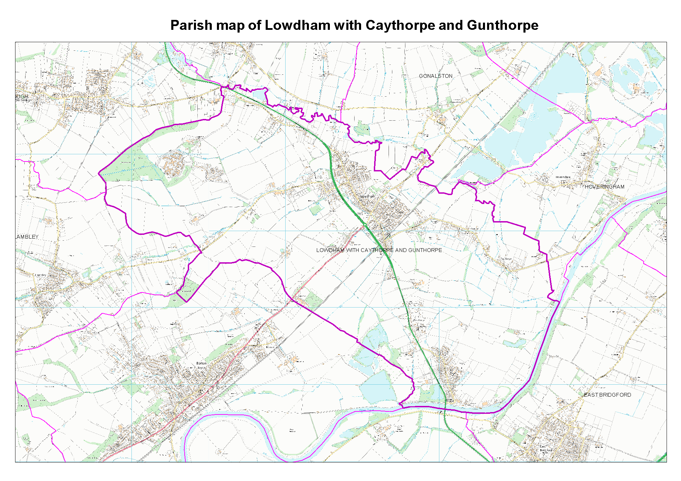

‘Feeding Minds, Touching Hearts’
SUPPLEMENTARY ADMISSION FORM

This form should be submitted to the school as well as applying through the Local Authority.

Name of Child: _____________________________

Child’s Date of Birth: ______________________________

The parent/carer of the above child has applied for a place at Gunthorpe Church of England Primary School, and have cited their Christian background as a reason for their choice.

Please ask your Vicar, Minister or Priest to complete the next part of this form and return it to you

To the Vicar, Minister or Priest: Please provide us with some supplementary information in support of this application:

To the Governors of the school:

I can confirm that __________________________________ (please enter the name(s) of the parent or carer (or their child)

Frequently (minimum monthly attendance) worships at the church listed below for at least the previous year.

OR

Is known to me and they have been involved in the life of the church listed below apart from regular worship for at least the previous year.

Name of Church: ______________________________

Address of Church: ____________________________

Signed ____________________________ Print _____________________________

Date: ___________________

Role in church if not clergy: _______________________________

Please note: In the event that during the period specified for attendance at worship the church has been closed for public worship and has not provided alternative premises for that worship, the requirements of these [admissions] arrangements in relation to attendance will only apply to the period when the church [or in relation to those of other faiths, relevant place of worship] or alternative premises have been available for public worship

